**Внимание.**

**Внимание**–  это сосредоточенность психической деятельности на определенном объекте. С помощью внимания обеспечивается отбор необходимой информации.

**Пример упражнений для развития внимания**

**Пройди лабиринт**

[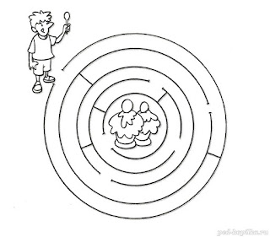](https://2.bp.blogspot.com/-Q3_mDjrt8lk/WZe81JmH0-I/AAAAAAAAATM/RxTpF_F2Z78UYRcvnMiMSaeO0PXeO2jOACLcBGAs/s1600/6d0ca076f7fea67c6f6512a9153230ed.jpg)

[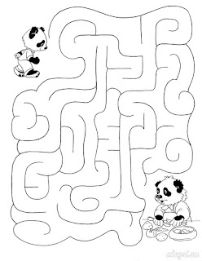](https://1.bp.blogspot.com/-BpG02MILKpU/WZe810QJo0I/AAAAAAAAATY/0Gy_tlkJshURRNkcen7V8EkML8pczV1IgCLcBGAs/s1600/8542516f8870173d7d1daba1daaaf0a1.jpg)

[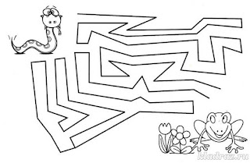](https://1.bp.blogspot.com/-Aw3D1OBR278/WZe81z9uEUI/AAAAAAAAATc/QVYaE4XQB60Z7ZheWxlOR-NML0LEutBqgCLcBGAs/s1600/9bc13833d3db27f5bde171feaaef699c.jpg)

[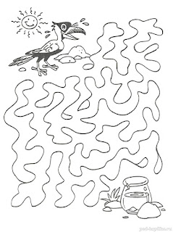](https://3.bp.blogspot.com/-XVcVBd2TokY/WZe81PzKQfI/AAAAAAAAATQ/C5DHxczY-Vc1E2AJYwbroHuGRxE6tpNUQCLcBGAs/s1600/47b2a46d017da3ab42371f940a0cbe3c.jpg)

[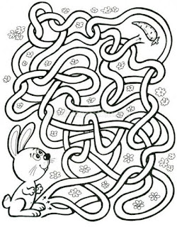](https://2.bp.blogspot.com/-RNkRB8Puxjw/WZe8zk8NqkI/AAAAAAAAASw/MfqJ7fxTc0gc3vSuEE2XhlTlCdCXD3WNQCLcBGAs/s1600/10551_c43b1e8f34c67f51c95f059028f0c4b1.jpg.jpg)

[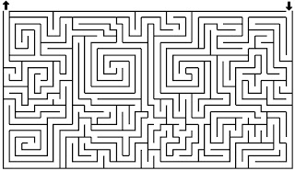](https://3.bp.blogspot.com/-8OopeghkP4E/WZe83wLMmAI/AAAAAAAAAT8/aOCdCBqA7dMtH-gsT8JX-ghKvAd6zqbYwCLcBGAs/s1600/labyrinthe-imprimer-32.jpg)

**Найди цифры в порядке возрастания, а затем в порядке убывания**

[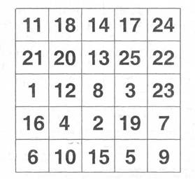](https://2.bp.blogspot.com/-lRZdDQpUWDY/WZe80fiZB5I/AAAAAAAAATE/UrSG62wJVVkTlaWil9wLdthwNyJ81mSOgCLcBGAs/s1600/4265466.jpeg)[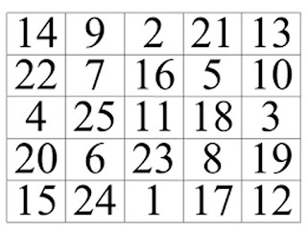](https://1.bp.blogspot.com/-G-ni7GZJE4s/WZe80f9OJSI/AAAAAAAAAS8/7Wpwm9s-HEsmras-L-T62CJYM6cG4U9LACLcBGAs/s1600/12-2.jpg)

[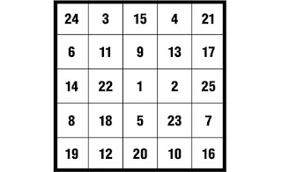](https://2.bp.blogspot.com/-POK2bHZarRw/WZe80Spw7bI/AAAAAAAAATA/6m1Z2gho4w8Xm9IzS5-lsVJu3SZ8ZiZegCLcBGAs/s1600/40232-MWM3OGEzZjg5NA.jpg)

[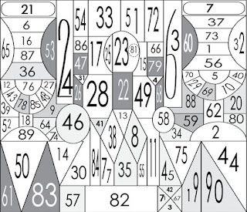](https://4.bp.blogspot.com/-RtLc5QniHpA/WZe84TlHZUI/AAAAAAAAAUI/LLGR1BIRIcYR00TAQFhxBsRgMjNb80XWwCLcBGAs/s1600/%D1%82%D0%B0%D0%B1%D0%BB%D0%B8%D1%86%D0%B0-1.jpg)

[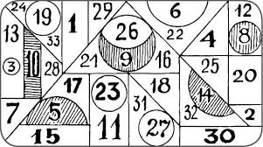](https://3.bp.blogspot.com/-a8nUlWbz2tI/WZe83OkOLLI/AAAAAAAAAT0/tYQG-tRrBgo9WUZiAFAcRae9UF7QzlN9QCLcBGAs/s1600/images.jpg)

**Найди буквы в алфавитной последовательности**[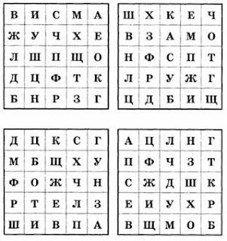](https://4.bp.blogspot.com/-crfCtPUzhe0/WZe82-WZiKI/AAAAAAAAATs/47IkA9pEOVQBOooJzwa5qb7kbGhERorXQCLcBGAs/s1600/eOPRGkGjxPY.jpg)

**Нарисуй в соответствующих фигурах соответствующие знаки начиная с первой строки**

[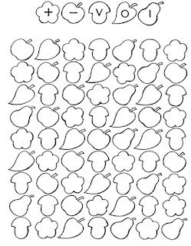](https://3.bp.blogspot.com/-fInfd5JsYL8/WZe8zq-hT1I/AAAAAAAAAS4/Gpq_nOiLQJogXiOUUt0cBTWIz71rCPyjQCLcBGAs/s1600/0017-009-Blank-korrekturnoj-proby-dlja-detej-test-Burdona.png)

[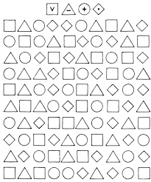](https://3.bp.blogspot.com/-NrZ9718N8Ss/WZe83ryH5OI/AAAAAAAAAT4/_bQaBt6TSrkoSq8IL4jCPpou_a3Fe5gQACLcBGAs/s1600/images.png)

[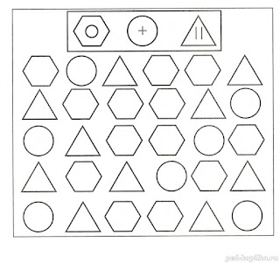](https://2.bp.blogspot.com/-ZcvzCYGoYg0/WZe82UWVklI/AAAAAAAAATg/mXPxMuO4y4gzpQrIOqQVs_YS-eCQNMKDgCLcBGAs/s1600/ad4f6be172342a5044e5d186e3755a58.jpg)

**Найди отличия**

[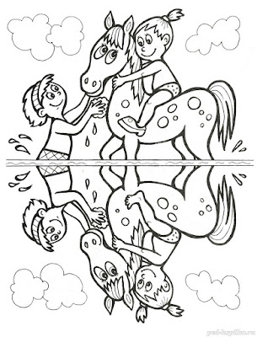](https://3.bp.blogspot.com/-8V0wLVCETfw/WZe81uvqRvI/AAAAAAAAATU/pEM1Di6fNEAhDWT1A_TKnUDKuBXLYTndACLcBGAs/s1600/84efbff55c12ac6c13042ae94b73bd2d.jpg)

**Найди пару к цифрам запиши получившиеся числа**

[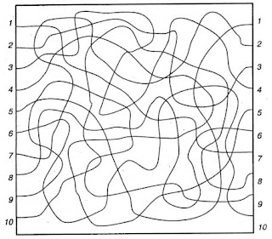](https://3.bp.blogspot.com/-YwpKUWv9FyE/WZe806hTagI/AAAAAAAAATI/yWytofbHXgM7FCT9BVE4bTNB0JAjl6mQACLcBGAs/s1600/47337837.jpg)

**Найди цифры и закрась участок в соответствии с условиями**

[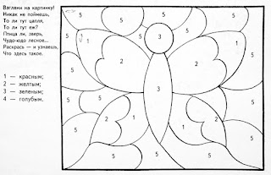](https://4.bp.blogspot.com/-Jlhict3ACOM/WZe8zpgPwsI/AAAAAAAAAS0/il61I9YmQXwkQ0LwyPxtywPEMA3r88-ZQCLcBGAs/s1600/117438502_large_DSCN0931.JPG)

[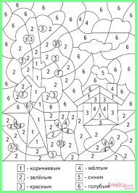](https://3.bp.blogspot.com/-jWQSMAAM_Hc/WZe83DEx6SI/AAAAAAAAATw/4ciAh9zWf8YEjDMw8KOOX662t_Leuq1cACLcBGAs/s1600/images+%281%29.png)

[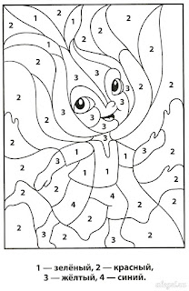](https://3.bp.blogspot.com/-0o8ZNcv0HBk/WZe82kknSsI/AAAAAAAAATo/Y2jZJ9U_j1oheaXWAb-Sn2qwVfga7N1YgCLcBGAs/s1600/cbc375f993a4235468cc806bc1bcad42.jpg)

**Найди и посчитай спрятанные фигуры**

[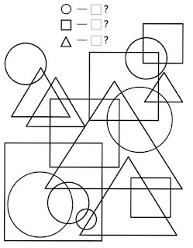](https://3.bp.blogspot.com/-iTbKT1TYAEY/WZe82fPEpfI/AAAAAAAAATk/qnbce0TIgr0JuXiqVao7XtqBvi46Oo3bQCLcBGAs/s1600/d170200999f07cf92235c08180189df6--matte.jpg)

[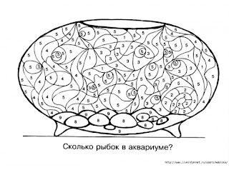](https://1.bp.blogspot.com/-yCuNfhhrHH0/WZe838I_FOI/AAAAAAAAAUA/U9rhgz9DbSACzbDV0n85MftxTf5gVQtjwCLcBGAs/s1600/mini_3.jpg)

[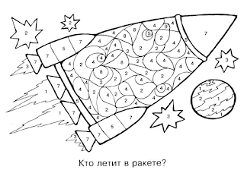](https://1.bp.blogspot.com/-K16DFFOSTMA/WZe84GkJw7I/AAAAAAAAAUE/diunQepLqbobUGfAPng75UgP9GSpS_VZwCLcBGAs/s1600/zadaniya5.gif)